# Continuous Testing, Pair Testing and Peer-to-Peer Testing

## Continuous Testing

### Definition:

**# Source**: **Chatgot (GPT-5-Standard) at [9/8/2025]**  
Continuous testing is the practice of running automated tests **as part of the software delivery pipeline**, so that you get **fast, ongoing feedback** on the quality of the software.

Instead of waiting until the end of a development cycle (like in traditional testing), tests are **executed continuously** whenever code changes happen — during build, integration, and deployment.

### Key points:

**# Source**: **Chatgot (GPT-5-Standard) at [9/8/2025]**

* ✅ Runs **automatically** (usually with CI/CD pipelines).
* ✅ Provides **immediate feedback** to developers.
* ✅ Helps detect defects **early** in the development process.
* ✅ Supports **faster release cycles** with higher confidence.
* ✅ Usually includes **unit, integration, API, UI, and performance tests**.

### Example:

**# Source**: **Chatgot (GPT-5-Standard) at [9/8/2025]**

* A developer pushes new code to GitHub.
* The CI/CD system (e.g., Jenkins, GitHub Actions, GitLab CI) automatically:
  1. Builds the application.
  2. Runs automated tests.
  3. Reports results — pass/fail — before deployment continues.

### 💡 In short:

**# Source**: **Chatgot (GPT-5-Standard) at [9/8/2025]**

Continuous testing = automated, ongoing verification of software quality during development, integrated into the delivery pipeline.

## Pair Testing

### Definition:

**# Source**: **Chatgot (GPT-5-Standard) at [9/8/2025]**  
Pair testing is when **two people** work **together at the same time on the same test** of a software feature, usually sharing one computer or session.

* Typically one is a **tester** and the other is **someone else involved in the product** (often a developer, but it could be a business analyst, product owner, designer, etc.).
* They explore, discuss, and test the feature in real time, combining **two perspectives**.

### How it works:

**# Source**: **Chatgot (GPT-5-Standard) at [9/8/2025]**

1. They pick a feature or a problem area.
2. Sit together (physically or virtually).
3. One may drive (operate the computer) while the other observes, asks questions, suggests ideas.
4. Switch roles if needed.

### Benefits:

**# Source**: **Chatgot (GPT-5-Standard) at [9/8/2025]**

* 🧠 Combines **different expertise** (e.g., dev knows code, tester knows test design).
* 🔎 Finds defects **faster** due to instant discussion and cross-checking.
* 📚 Improves **knowledge sharing** — both learn from each other.
* 🏃 Speeds up understanding of complex or risky features.

### Example scenario:

**# Source**: **Chatgot (GPT-5-Standard) at [9/8/2025]**

* A new payment module is nearly finished.
* A tester and a developer run through various payment flows together.
* The tester suggests edge cases; the developer explains constraints.
* They discover a bug in how refunds are handled, fix it right away.

### 💡 In short:

**# Source**: **Chatgot (GPT-5-Standard) at [9/8/2025]**

Pair testing sessions = two people testing together in real time, combining skills and perspectives to improve test coverage and speed up defect discovery.

## Peer-to-Peer Testing

### Definition:

**# Source**: **Chatgot (GPT-5-Standard) at [9/8/2025]**  
Peer-to-peer testing is when **colleagues (peers)** test each other’s work. Instead of testing being done only by a separate QA team, people at the same level — like developers testing code written by other developers — **exchange roles** to verify quality.

It’s basically a form of **cross-checking** between equals.

### How it works:

**# Source**: **Chatgot (GPT-5-Standard) at [9/8/2025]**

1. Developer/Tester A writes a piece of code or test cases.
2. Developer/Tester B (a peer) reviews and tests A’s work.
3. They swap — B’s work is tested by A or another peer.

This can be structured (with formal plans) or informal (quick sanity checks).

### Benefits:

**# Source**: **Chatgot (GPT-5-Standard) at [9/8/2025]**

* 🧠 **Fresh eyes** — someone else may notice what the author missed.
* 🤝 **Collaboration** — encourages knowledge sharing and teamwork.
* ⚡ **Faster feedback** — no waiting for a separate team or cycle.
* 🏆 **Higher quality** — reduces confirmation bias (the author is less likely to miss their own mistakes).

### Example:

**# Source**: **Chatgot (GPT-5-Standard) at [9/8/2025]**

* Two testers are working on different modules of a mobile app.
* Before final QA, each tests the other’s module for usability and logic errors.
* They catch small issues early, reducing bugs in later stages.

### 💡 In short:

**# Source**: **Chatgot (GPT-5-Standard) at [9/8/2025]**

Peer-to-peer testing = testing performed by colleagues at the same level, exchanging roles to validate each other’s work and improve quality through collaborative review.

### is Peer-to-Peer Testing same Pair Testing?

**# Source**: **Chatgot (GPT-5-Standard) at [9/8/2025]**

No — **Peer-to-Peer Testing** and **Pair Testing** are **not the same**, even though both involve collaboration.

Here’s a side-by-side comparison:

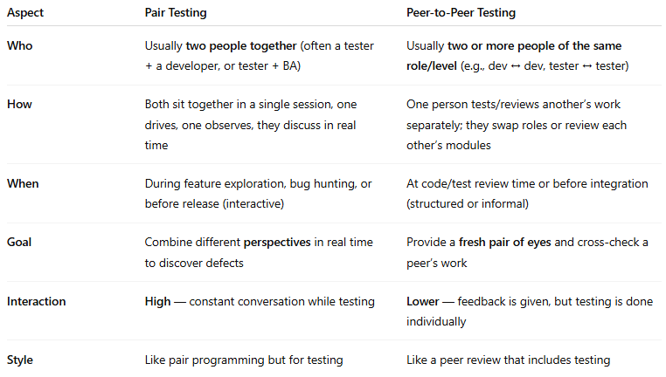

| **Aspect** | **Pair Testing** | **Peer-to-Peer Testing** |
| --- | --- | --- |
| **Who** | Usually **two people together** (often a tester + a developer, or tester + BA) | Usually **two or more people of the same role/level** (e.g., dev ↔ dev, tester ↔ tester) |
| **How** | Both sit together in a single session, one drives, one observes, they discuss in real time | One person tests/reviews another’s work separately; they swap roles or review each other’s modules |
| **When** | During feature exploration, bug hunting, or before release (interactive) | At code/test review time or before integration (structured or informal) |
| **Goal** | Combine different **perspectives** in real time to discover defects | Provide a **fresh pair of eyes** and cross-check a peer’s work |
| **Interaction** | **High** — constant conversation while testing | **Lower** — feedback is given, but testing is done individually |
| **Style** | Like pair programming but for testing | Like a peer review that includes testing |

💡 **Quick summary:**

* **Pair testing** = two people testing **together** in the same session.
* **Peer-to-peer testing** = colleagues testing **each other’s work**, not necessarily together.